PROJECT DESCRIPTION: Operation Analytics is the analysis done for the complete end to end operations of a company. With the help of this, the company then finds the areas on which it must improve upon. Being one of the most important parts of a company, this kind of analysis is further used to predict the overall growth or decline of a company’s fortune. It means better automation, better understanding between cross-functional teams, and more effective workflows.

**Number of jobs reviewed:**Amount of jobs reviewed over time.  
**Your task:** Calculate the number of jobs reviewed per hour per day for November 2020?

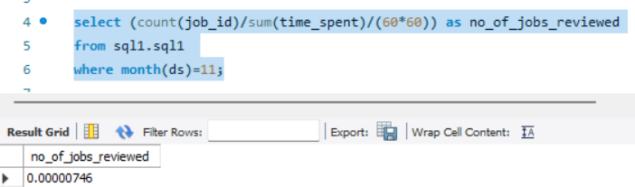

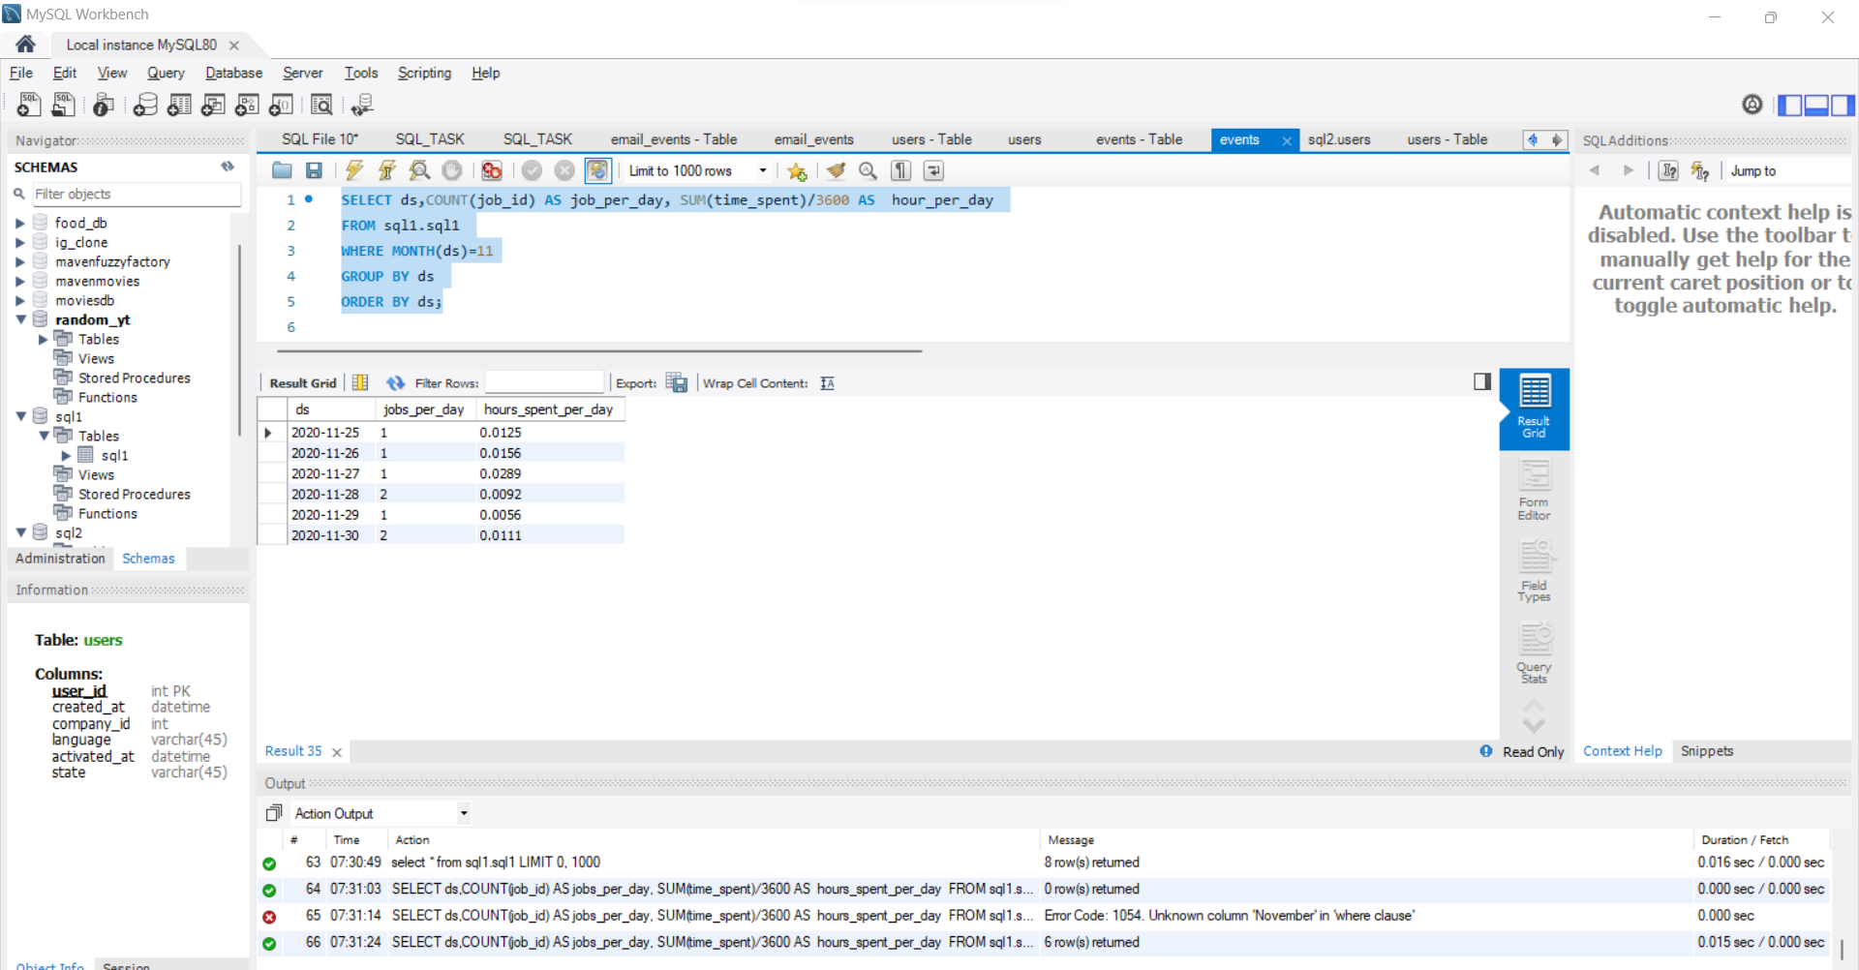

**Throughput:**It is the no. of events happening per second.  
**Your task:** Let’s say the above metric is called throughput. Calculate 7 day rolling average of throughput? For throughput, do you prefer daily metric or 7-day rolling and why?

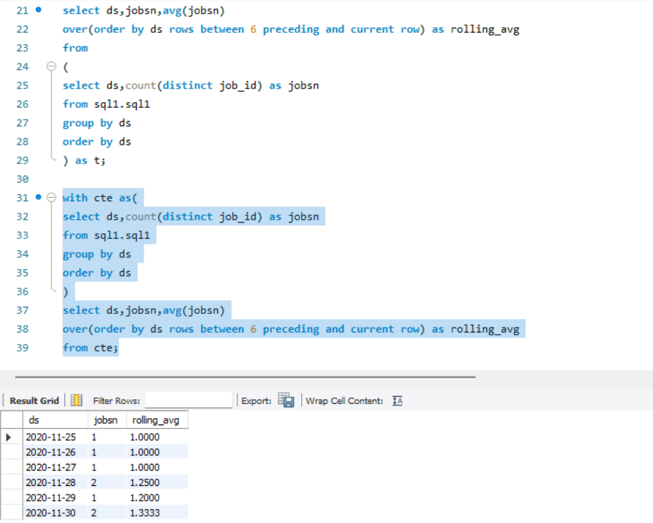

**Percentage share of each language:**Share of each language for different contents.  
**Your task:** Calculate the percentage share of each language in the last 30 days?

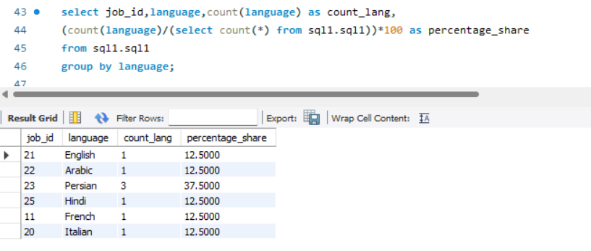

**Duplicate rows:**Rows that have the same value present in them.  
**Your task:** Let’s say you see some duplicate rows in the data. How will you display duplicates from the table?

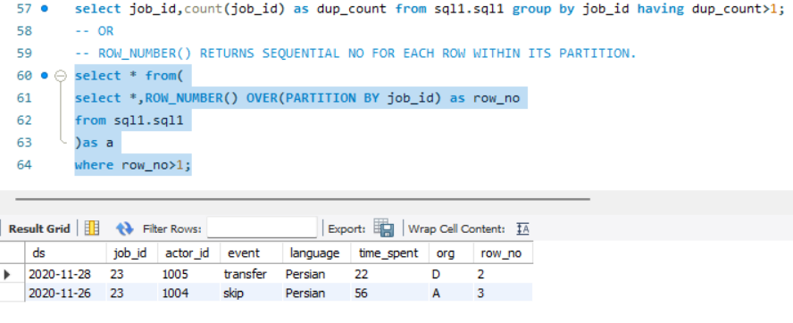

**User Engagement:**To measure the activeness of a user. Measuring if the user finds quality in a product/service.  
**Your task:** Calculate the weekly user engagement.

select extract(week from occured_at) as week,

count(distinct user_id) as "active users"

from sql2.events

where event_type='engagement'

group by week;

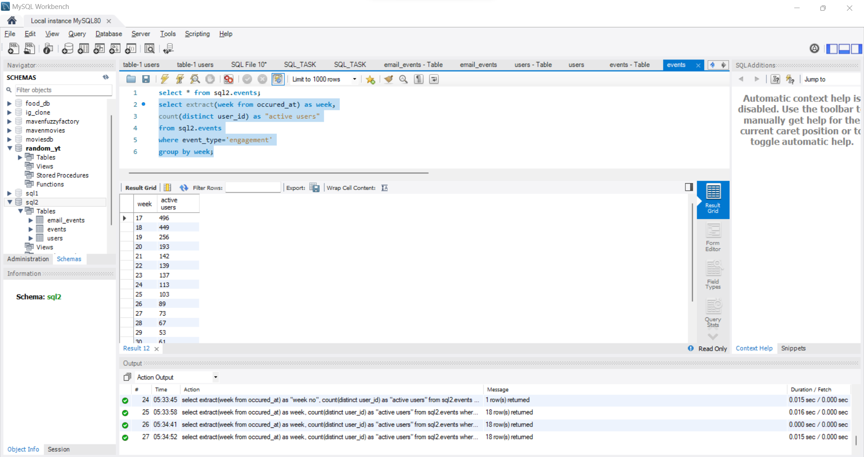

SELECT week_number, COUNT(DISTINCT user_id) as number_of_users

FROM (

SELECT user_id, datepart(week, occurred_at) as week_number

FROM email_events

) subquery

GROUP BY week_number;

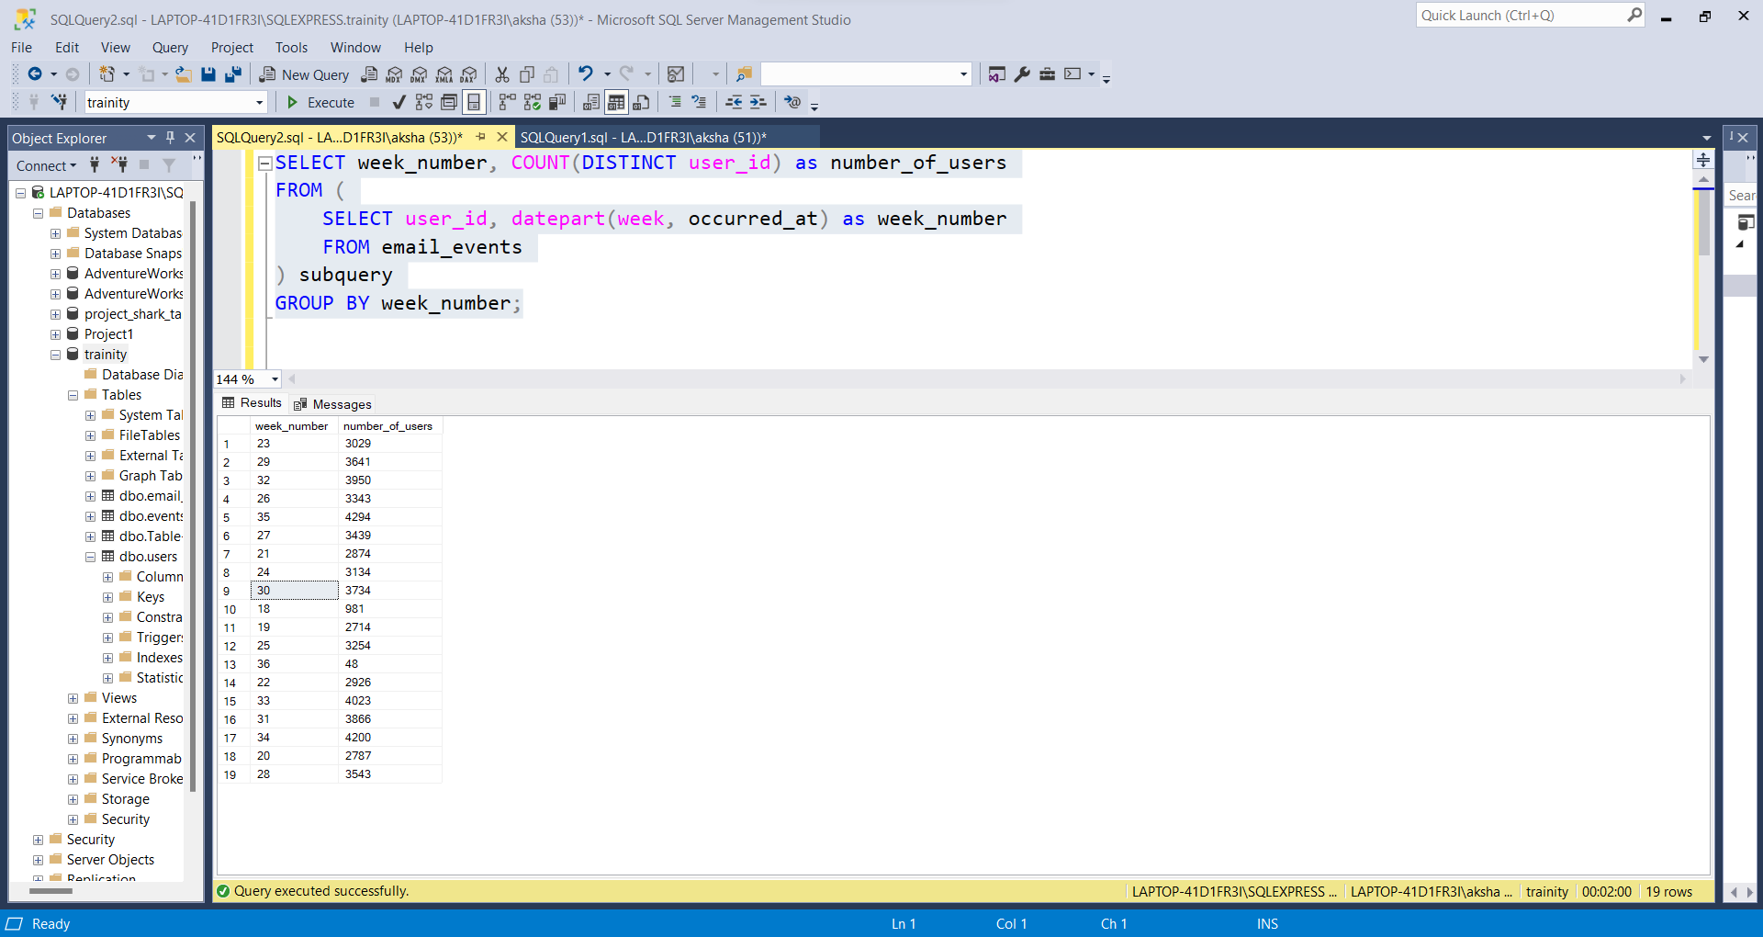

**User Growth:**Amount of users growing over time for a product.  
**Your task:** Calculate the user growth for the product.

select * from users;

select

year,

weeknum,

new_active_user,

sum(new_active_user) over (order by year,weeknum rows between unbounded preceding and current row) as cum_active_user

from

(

select

year(activated_at) as year,

datepart(week,activated_at) as weeknum,

count(distinct user_id) as new_active_user

from

users

where

state='active'

group by

YEAR(activated_at), DATEPART(week, activated_at)

)a;

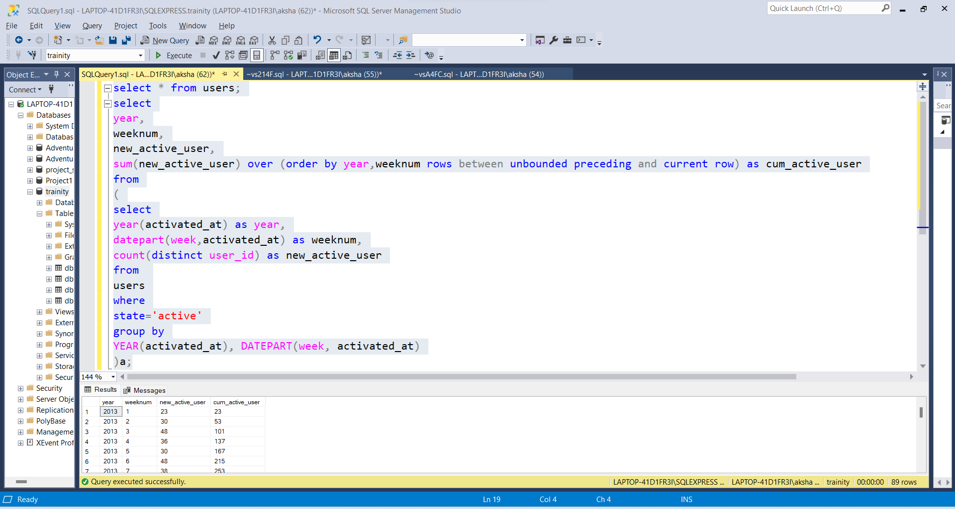

**Weekly Retention:**Users getting retained weekly after signing-up for a product.  
**Your task:** Calculate the weekly retention of users-sign up cohort?

SELECT

first AS [Week Numbers],

SUM(CASE WHEN week_number = 0 THEN 1 else 0 end) as [week 0],

SUM(CASE WHEN week_number = 1 THEN 1 else 0 end) as [week 1],

SUM(CASE WHEN week_number = 2 THEN 1 else 0 end) as [week 2],

SUM(CASE WHEN week_number = 3 THEN 1 else 0 end) as [week 3],

SUM(CASE WHEN week_number = 4 THEN 1 else 0 end) as [week 4],

SUM(CASE WHEN week_number = 5 THEN 1 else 0 end) as [week 5],

SUM(CASE WHEN week_number = 6 THEN 1 else 0 end) as [week 6],

SUM(CASE WHEN week_number = 7 THEN 1 else 0 end) as [week 7],

SUM(CASE WHEN week_number = 8 THEN 1 else 0 end) as [week 8],

SUM(CASE WHEN week_number = 9 THEN 1 else 0 end) as [week 9],

SUM(CASE WHEN week_number = 10 THEN 1 else 0 end) as [week 10],

SUM(CASE WHEN week_number = 11 THEN 1 else 0 end) as [week 11],

SUM(CASE WHEN week_number = 12 THEN 1 else 0 end) as [week 12],

SUM(CASE WHEN week_number = 13 THEN 1 else 0 end) as [week 13],

SUM(CASE WHEN week_number = 14 THEN 1 else 0 end) as [week 14],

SUM(CASE WHEN week_number = 15 THEN 1 else 0 end) as [week 15],

SUM(CASE WHEN week_number = 16 THEN 1 else 0 end) as [week 16],

SUM(CASE WHEN week_number = 17 THEN 1 else 0 end) as [week 17],

SUM(CASE WHEN week_number = 18 THEN 1 else 0 end) as [week 18]

FROM (

SELECT m.user_id, m.login_week, n.first, m.login_week - first AS week_number

FROM

(

SELECT user_id, DATEPART(WEEK, occurred_at) AS login_week

FROM events

GROUP BY user_id, DATEPART(WEEK, occurred_at)

) m

INNER JOIN

(

SELECT user_id, MIN(DATEPART(WEEK, occurred_at)) AS first

FROM events

GROUP BY user_id

) n ON m.user_id = n.user_id

) sub

GROUP BY first

ORDER BY first;

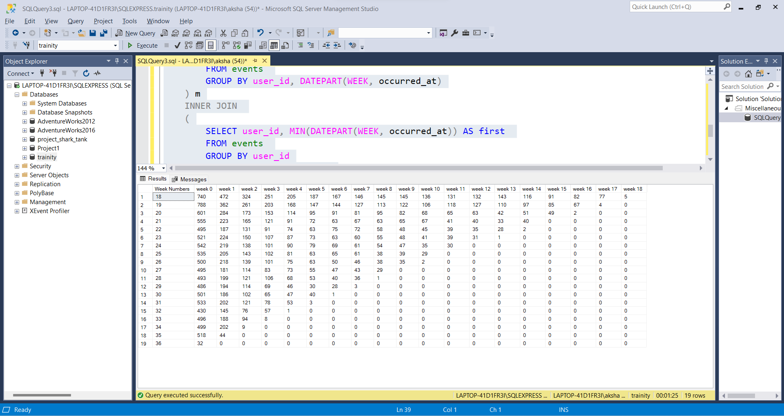

MYSQL QUERY->

SELECT first AS "Week Numbers",

SUM(CASE WHEN week_number = 0 THEN 1 else 0 end) as 'week 0',

SUM(CASE WHEN week_number = 1 THEN 1 else 0 end) as 'week 1',

SUM(CASE WHEN week_number = 2 THEN 1 else 0 end) as 'week 2',

SUM(CASE WHEN week_number = 3 THEN 1 else 0 end) as 'week 3',

SUM(CASE WHEN week_number = 4 THEN 1 else 0 end) as 'week 4',

SUM(CASE WHEN week_number = 5 THEN 1 else 0 end) as 'week 5',

SUM(CASE WHEN week_number = 6 THEN 1 else 0 end) as 'week 6',

SUM(CASE WHEN week_number = 7 THEN 1 else 0 end) as 'week 7',

SUM(CASE WHEN week_number = 8 THEN 1 else 0 end) as 'week 8',

SUM(CASE WHEN week_number = 9 THEN 1 else 0 end) as 'week 9',

SUM(CASE WHEN week_number = 10 THEN 1 else 0 end) as 'week 10',

SUM(CASE WHEN week_number = 11 THEN 1 else 0 end) as 'week 11',

SUM(CASE WHEN week_number = 12 THEN 1 else 0 end) as 'week 12',

SUM(CASE WHEN week_number = 13 THEN 1 else 0 end) as 'week 13',

SUM(CASE WHEN week_number = 14 THEN 1 else 0 end) as 'week 14',

SUM(CASE WHEN week_number = 15 THEN 1 else 0 end) as 'week 15',

SUM(CASE WHEN week_number = 16 THEN 1 else 0 end) as 'week 16',

SUM(CASE WHEN week_number = 17 THEN 1 else 0 end) as 'week 17',

SUM(CASE WHEN week_number = 18 THEN 1 else 0 end) as 'week 18'

FROM (

SELECT m.user_id, m.login_week, n.first, m.login_week - first AS week_number

FROM

(SELECT user_id, EXTRACT(WEEK FROM occured_at) AS login_week from

sql2.events GROUP BY 1, 2) m,

(SELECT user_id, MIN(EXTRACT(WEEK FROM occured_at)) AS first from

sql2.events GROUP BY 1) n

WHERE m.user_id = n.user_id) sub

GROUP BY first

ORDER BY first;

**Weekly Engagement:**To measure the activeness of a user. Measuring if the user finds quality in a product/service weekly.  
**Your task:** Calculate the weekly engagement per device?

SELECT

YEAR(occurred_at) AS year_num,

DATEPART(WEEK, occurred_at) AS week_num,

device,

COUNT(DISTINCT user_id) AS no_of_users

FROM

events

WHERE

event_type = 'engagement'

GROUP BY

YEAR(occurred_at),

DATEPART(WEEK, occurred_at),

device

ORDER BY

YEAR(occurred_at),

DATEPART(WEEK, occurred_at),

device;

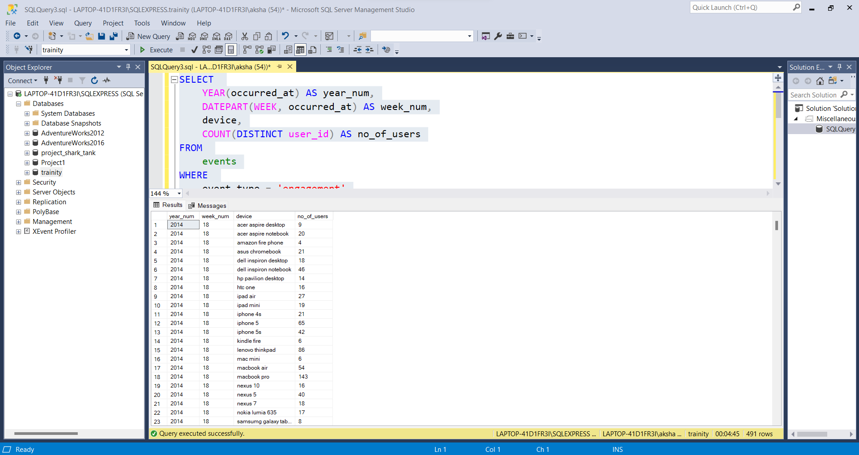

MYSQL QUERY->

SELECT

extract(year from occured_at) as year_num,

extract(week from occured_at) as week_num,

device,

COUNT(distinct user_id) as no_of_users

FROM

sql2.events

where event_type = 'engagement'

GROUP by 1,2,3

order by 1,2,3;

**Email Engagement:**Users engaging with the email service.  
**Your task:** Calculate the email engagement metrics?

SELECT

DATEPART(WEEK, occurred_at) AS week,

ROUND((SUM(CASE WHEN action = 'sent_weekly_digest' THEN 1 ELSE 0 END) / CAST(COUNT(user_id) AS FLOAT) * 100), 2) AS 'Weekly Digest Rate',

ROUND((SUM(CASE WHEN action = 'email_open' THEN 1 ELSE 0 END) / CAST(COUNT(user_id) AS FLOAT) * 100), 2) AS 'Email Open Rate',

ROUND((SUM(CASE WHEN action = 'email_clickthrough' THEN 1 ELSE 0 END) / CAST(COUNT(user_id) AS FLOAT) * 100), 2) AS 'Email Clickthrough Rate',

ROUND((SUM(CASE WHEN action = 'sent_reengagement_email' THEN 1 ELSE 0 END) / CAST(COUNT(user_id) AS FLOAT) * 100), 2) AS 'Reengagement Email'

FROM

email_events

GROUP BY

DATEPART(WEEK, occurred_at)

ORDER BY

DATEPART(WEEK, occurred_at);

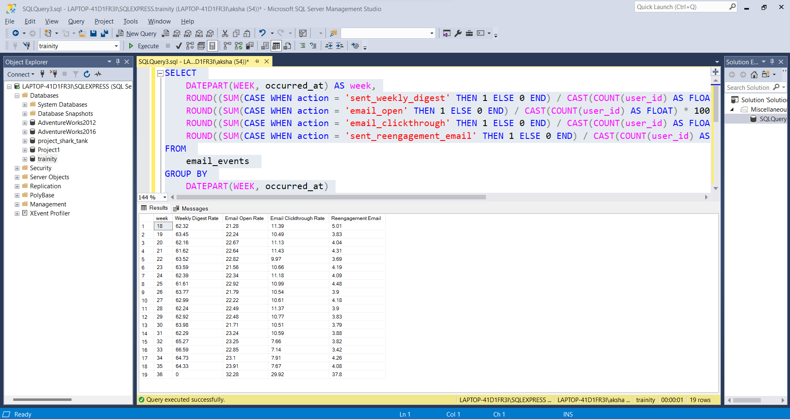

MYSQL QUERY->

SELECT Week,

ROUND((weekly_digest/total*100),2) as 'Weekly Digest Rate',

ROUND((email_opens/total*100),2) as 'Email Open Rate',

ROUND((email_clickthroughs/total*100),2) as 'Email Clickthrough Rate',

ROUND((reengagement_emails/total*100),2) as 'Reengagement Email'

FROM

(

SELECT EXTRACT(WEEK FROM occured_at) as week,

COUNT(CASE WHEN action = 'sent_weekly_digest' then user_id else null end)

as weekly_digest,

COUNT(CASE WHEN action = 'email_open' then user_id else null end) as

email_opens,

COUNT(CASE WHEN action = 'email_clickthrough' then user_id else null end)

as email_clickthroughs,

COUNT(CASE WHEN action = 'sent_reengagement_email' then user_id else null

end) as reengagement_emails,

COUNT(user_id) AS total

FROM sql2.email_events

GROUP BY 1 ) sub

GROUP BY 1

ORDER BY 1;